**DirectAthletics**

Directathletics.com

username: ubc

password: DEY6D

**Creating a Meet**

* Go to Meet Manager and choose “Create New Meet From a Template” and choose the appropriate one. 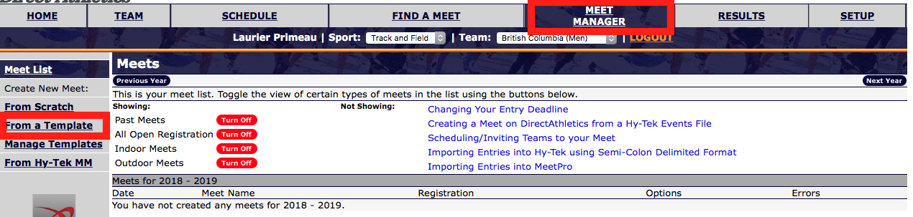
* Press Create  
  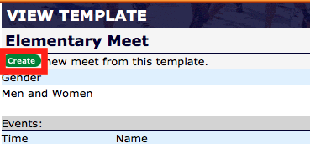
* We’ve had some issues with registration closing early (it might be on GMT), so add an additional 8 hours to the entry deadline than what you publicize on the meet package. Press Submit.
* Now Press “Edit Meet’s Attributes”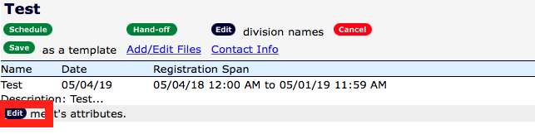
* The most important part is the payment section. Make individual athletes pay online, then you don’t have to fuss around with collecting small payments and chasing down individuals. Allow teams to pay online or in person. To do that use the options as shown. Add a team cap for the UBC Open, not the elementary. This team cap will be per gender.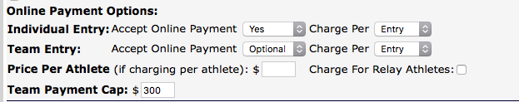
* Make the schedules hidden so you don’t have to mess around with them here.
* Now to edit the events. Select all then click “edit selected”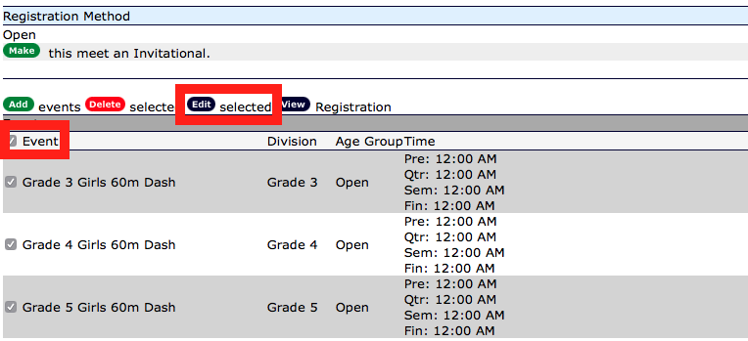
* Always keep Age Group Open and have aging done by Division to avoid complication for teachers registering without entering every athletes birthday. Here is also where you change the price per event. DO NOT change the way the events are named or you may break the Excel program later. 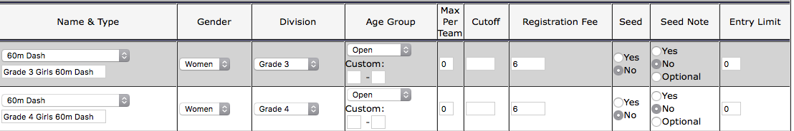

**Exporting the Entries and Finding Billing Info**

* Click on “View Registration”  
  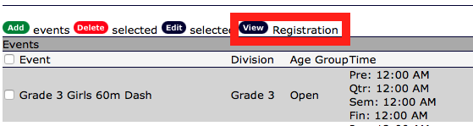
* To fill in your Excel Number form: Choose “Registration by Athlete.” Then choose “Team” and “Event”. Press Export Results to Excel. If you find any errors when following the directions in the “How To – Excel” guide, come back here and choose “Retrieve” instead to see what values got corrupted on the export.   
  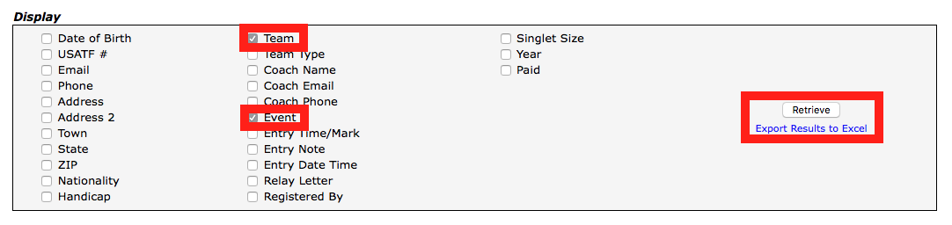
* To fill in your Excel Invoice Form: Choose “Registration by Team” instead. Check off the following boxes and then retrieve.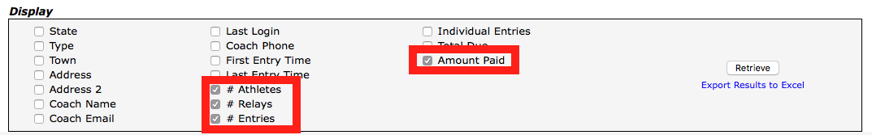
* To get the entries ready for MeetPro: Click on Downloads from the Edit page. And follow the directions on that page. 